EXPERIMENT – 17
Mobile Price Prediction using an Appropriate Machine Learning Algorithm
AIM
To implement a Mobile Price Prediction model using an appropriate machine learning algorithm in Python.
APPARATUS REQUIRED
- Google Colab
- Python 3.x
- NumPy
ALGORITHM
- Start the program.
- Import the required Python libraries.
- Create or load the mobile price dataset.
- Preprocess the dataset.
- Select the input features and target variable.
- Split the dataset into training and testing data.
- Create a suitable machine learning classification model.
- Train the model using the training data.
- Predict the price range of mobile phones using the test data.
- Calculate the accuracy of the model.
- Display the prediction results.
- Stop the program.
PROGRAM
# Experiment 17: Mobile Price Prediction
# Import required libraries
import numpy as np
import pandas as pd

from sklearn.model_selection import train_test_split
from sklearn.ensemble import RandomForestClassifier
from sklearn.metrics import accuracy_score, confusion_matrix

# Create sample mobile dataset
data = {
"RAM": [2, 3, 4, 4, 6, 6, 8, 8, 12, 12],
"Storage": [32, 32, 64, 128, 128, 256, 128, 256, 256, 512],
"Battery": [3000, 3500, 4000, 4500, 4500,
5000, 5000, 5000, 5500, 6000],
"Camera": [12, 13, 16, 20, 24, 32, 48, 50, 64, 108],
"Price_Range": [
0, 0, 1, 1, 1,
2, 2, 2, 3, 3
]
}
df = pd.DataFrame(data)
# Separate features and target
X = df[["RAM", "Storage", "Battery", "Camera"]]
y = df["Price_Range"]
# Split the dataset
X_train, X_test, y_train, y_test = train_test_split(
X, y, test_size=0.2, random_state=42
)

# Create Random Forest classifier
model = RandomForestClassifier(
n_estimators=100,
random_state=42
)
# Train the model
model.fit(X_train, y_train)
# Predict price range
y_pred = model.predict(X_test)
# Calculate accuracy
accuracy = accuracy_score(y_test, y_pred)
print("Actual Price Range:")
print(y_test.values)
print("\nPredicted Price Range:")
print(y_pred)
print("\nAccuracy:", accuracy)
# Display confusion matrix
cm = confusion_matrix(y_test, y_pred)
print("\nConfusion Matrix:")
print(cm)
# Predict price range for a new mobile
new_mobile = [[8, 256, 5000, 50]]
prediction = model.predict(new_mobile)
print("\nPredicted Price Range:", prediction[0])

OUTPUT
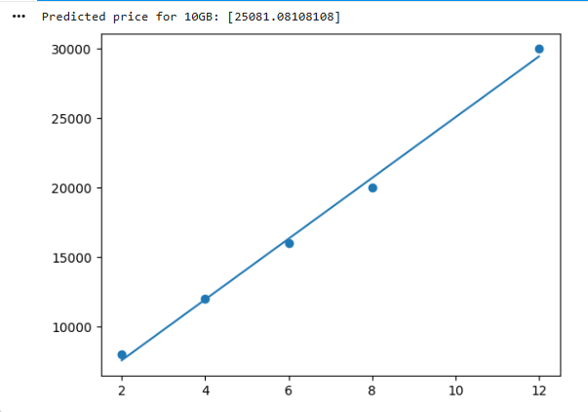
RESULT
Thus, the Mobile Price Prediction model was successfully implemented using Python in Google Colab, and the price range of mobile phones was predicted using a machine learning algorithm.

